PROGRAM INFORMATION / TECHNICAL VISITS
(The following items should be compiled by the program instructor and available to the team at the designated meeting site prior to the classroom visit. In addition, frameworks, lesson plans, CTSO materials and Perkins funded equipment will need to be available in the classroom for review. All documentation should reflect a 5 year history unless otherwise noted.)
1. Program Description
- Describe any changes recently implemented in the program.
- Describe any anticipated or planned program changes.
- In what respects is this program most satisfactory and commendable?
- In what respects is this program most in need of improvement?
- What steps are recommended for the correction of program weaknesses?
- Describe public relations activities and include samples.
- Provide copies of the Teacher Information System (TIS) report (current year and past 4 years). If the program has been Approved-Conditional or Disapproved during that time, include a copy of the school's response letter to that status.
2. Program of Study
- Provide a class roster (current year only).
- Include copies of completer records maintained in the department.
- If substitution course is used in place of a foundation course, include copy of letter requesting permission and response letter from DWE.
3. Perkins Funding
- Describe how Perkins funds have been utilized in the program. Give examples of in-service, supplies and materials, activities, and the indicator addressed.
- List program equipment purchased with Perkins Funds.
4. Integration
- Describe integration activities carried out in the program.
- Provide examples (paper or electronic) of student work on integration projects (current year only).
- Include sample lesson plans documenting academic competencies (current year only).

5. Curriculum & Assessment
- Describe how Arkansas frameworks followed in all classroom instruction.
- Provide sample lesson plans documenting the use of frameworks (current year only).
- Provide sample lesson plans documenting the use of technology in the classroom (current year only).
- Provide copies of competency testing records.
6. Career & Technical Student Organization
- Describe activities of the student organization.
- Include student organization roster (current year only).
- Include proof of affiliation (current year only).
7. Advisory Committee/Council
- Describe the activity of the Advisory Committee/Council.
- Include lists of Advisory Committee/Council members with occupation.
- Include copies of the Advisory Committee/Council minutes documenting a minimum of 2 meetings per year.
8. Professional Development
- Include list of in-service attendance noting subject area related in-service.
- List professional memberships held by the instructor.
- Describe instructor's activity in professional organizations.
9. Program Operation
- List equipment purchased with state or local funds.
- Include a copy of the department inventory (current year only).

Career and Technical Education Technical Assistance Visits Five-Year Cycle

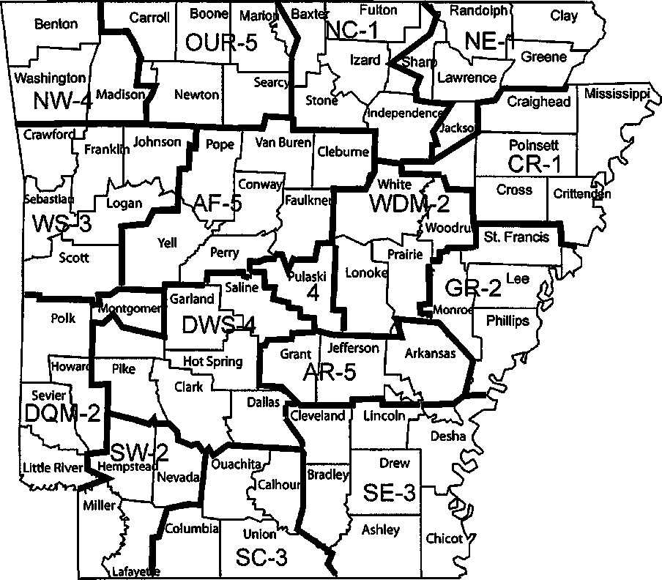

Arkansas Education Service Cooperatives
AF - Arch Ford
AR - Arkansas River
CR - Crowley's Ridge
DWS • Dawson
DQM - De Queen/Mena
GR - Great Rivers
NC-North Central
NE - Northeast
NW-Northwest
OUR - Ozarks Unlimited Resources
SC - South Central
SE - Southeast
SW - Southwest
WS-Western
WDM-Wilbur D.Mills
Year 1 - 2008-2009 Year 2-2009-2010 Year 3-2010-2011 Year 4-2011-2012 Year 5-2012-2013

