

Ann Webb,Gifted Education Specialist

1013 Haley Street, Melbourne, AR 72556

870-368-7955 ann.webb@northcentral.k12.ar.us.

**Highlights:**

**August 19**

Fredi Lajrardi, nationally recognized STEM educator, was at UACCB on September 15.

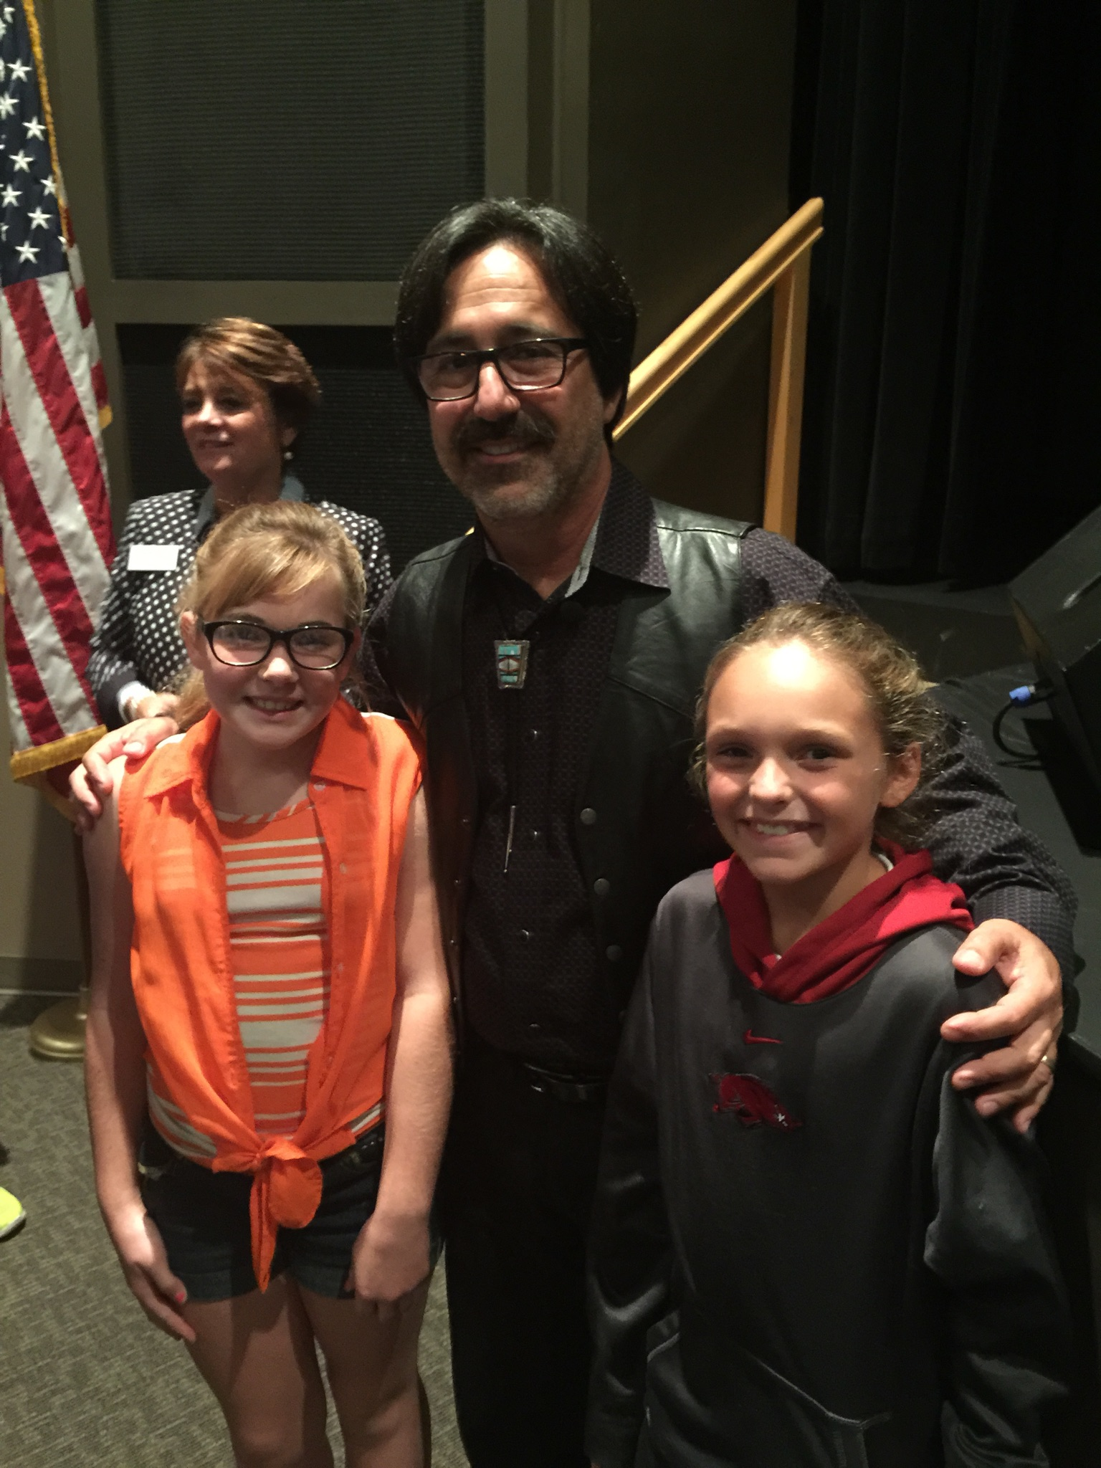

“The art of teaching is the art of assisting discovery.”

Mark van Doren

“The art of teaching is the art of assisting discovery.” Mark van Doren

**Calendar:**

**August 28—Gifted and Talented Annual Teleconference**

**September 11 - AAGEA Conference at Conway**

**September 28 – Collaboration-Professional Development at Northcentral Service Cooperative**

The Gifted and Talented Program approval deadline is October 15.

Northcentral Arkansas Service

Cooperative

July – September, 2015

*Advocating Opportunities for Gifted and Talented Students to grow and shine,*

**ARKANSAS GEMS**