

Ann Webb,Gifted Education Specialist

1013 Haley Street, Melbourne, AR 72556

870-368-7955 ann.webb@northcentral.k12.ar.us.

**Highlights:**

August 19

Fredi Lajrardi, nationally recognized STEM educator, was at UACCB on September 15.

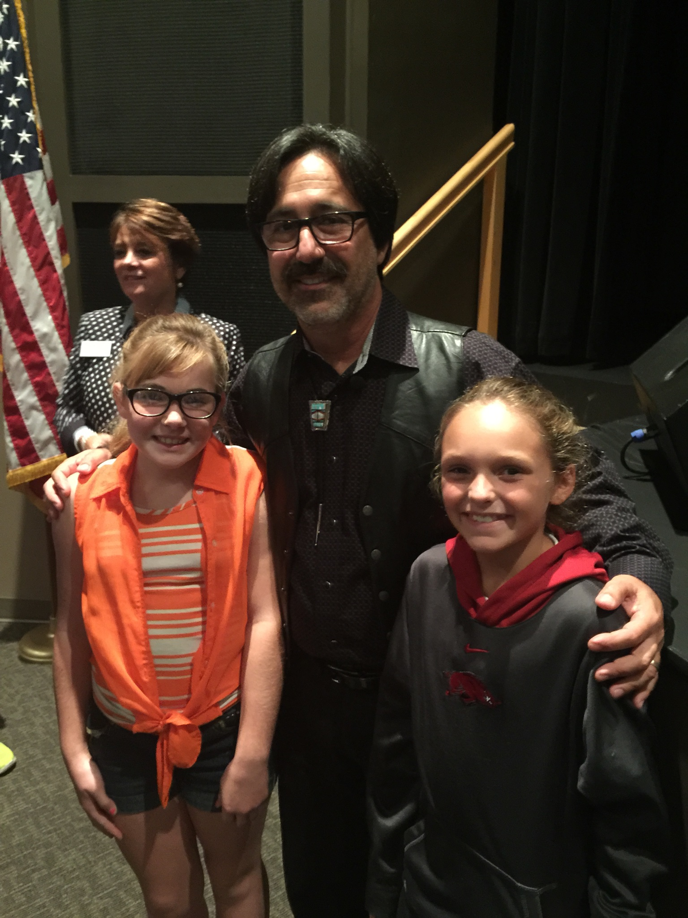

“The art of teaching is the art of assisting discovery.”

Mark van Doren

“The art of teaching is the art of assisting discovery.” Mark van Doren

**Calendar:**

**October 8—Junior/Senior High Chess Tournament**

**October 15 – Gifted and Talented Program Approval Application Due**

**December 9 –Junior High Quiz Bowl at Ozarka College**

Northcentral Arkansas Service

Cooperative

October – December, 2015

*Advocating Opportunities for Gifted and Talented Students to grow and shine,*

**ARKANSAS GEMS**